
Name:___________________________________

Date:_____________________ Hour:_________

We know that we can simplify the product of powers that have the same exponent.
Example: 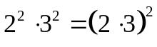
Similarly you can simplify the product of radicals that have the same index.
Example: 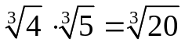

Product Property If 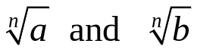 are real numbers, then 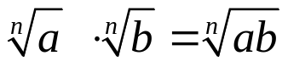

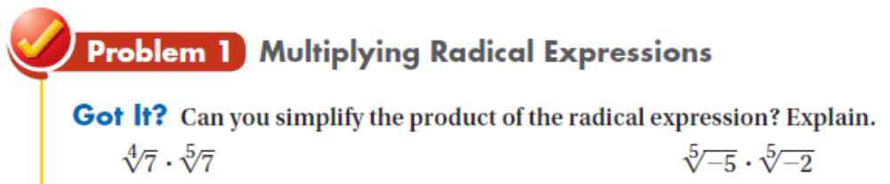

Multiply, if possible. Then simplify.

1. 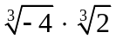 2. 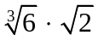 3. 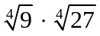

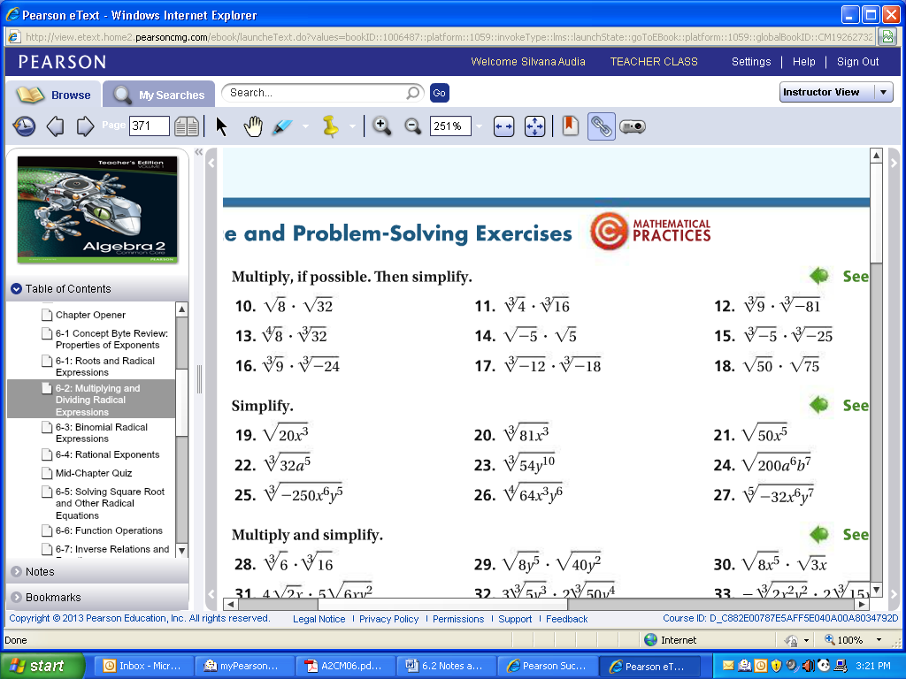



Simplify

4. 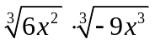 5. 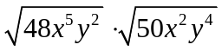 6. 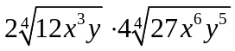



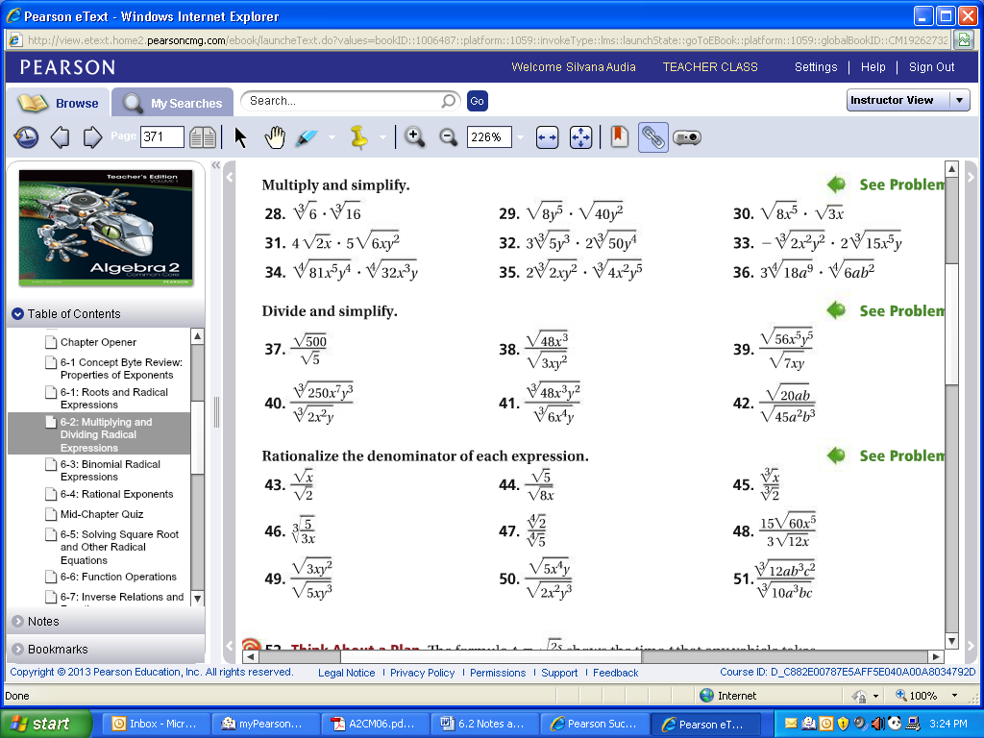

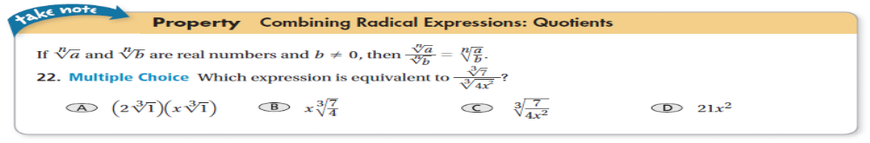

Quotient Property If are real numbers and 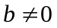, then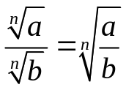

Remember for a radical to be simplified:
- there can not be a radical in the denominator of a fraction
- there can not be a fraction inside of a radical

To take care of the radical in the denominator, we RATIONALIZE the denominator. Get rid of the radical in the denominator.

7. 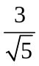 8 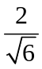 9.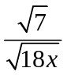



Divide and simplify.

8. 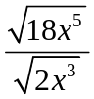 9. 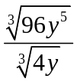 10. 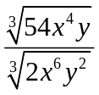

11. 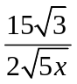 12. 



