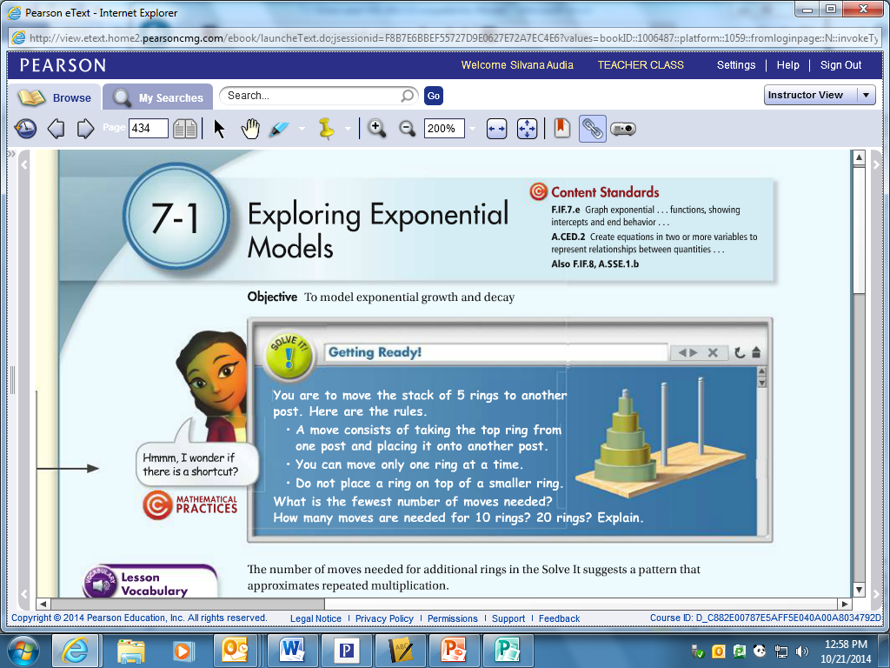

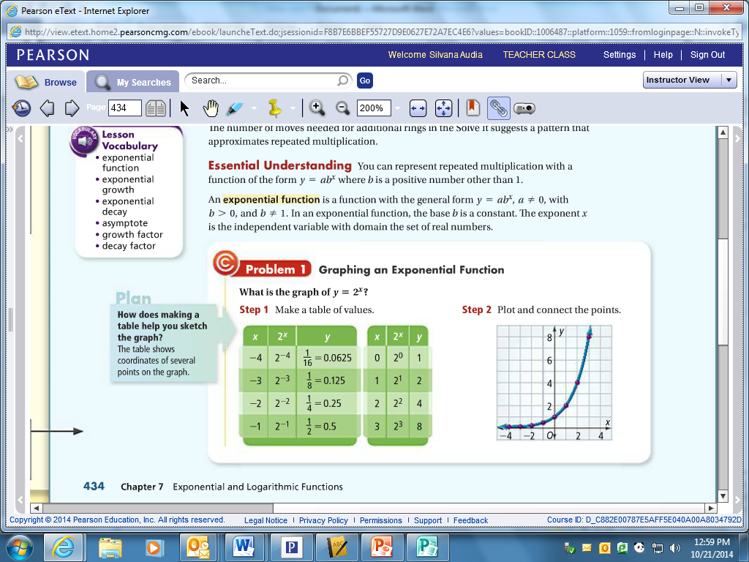

|  |  |
| --- | --- |
| X | Y |
|  |  |
|  |  |
|  |  |
|  |  |
|  |  |

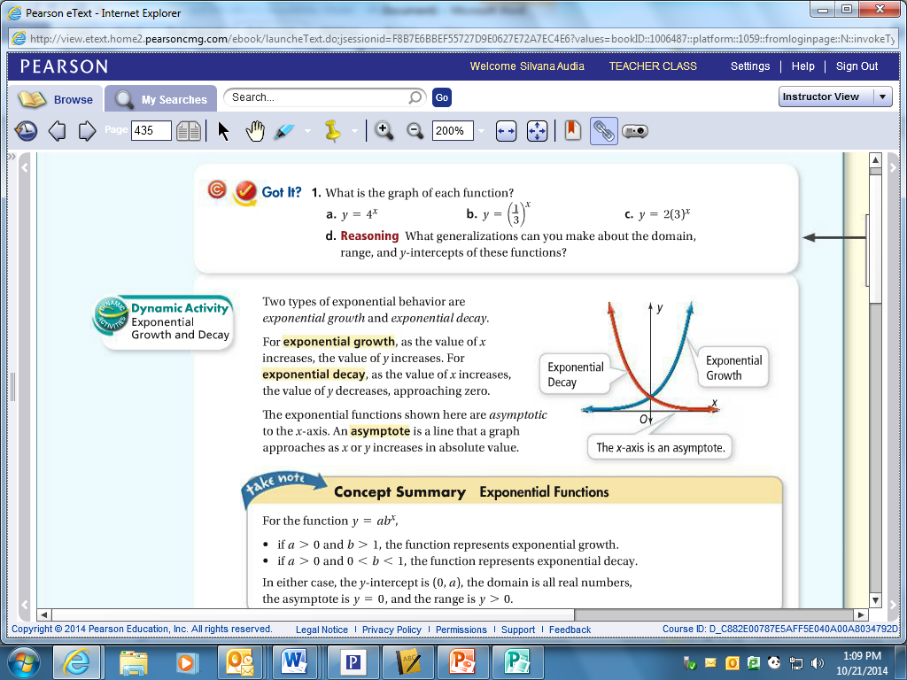

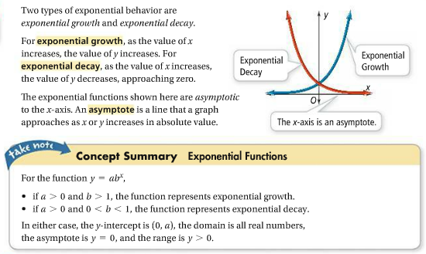

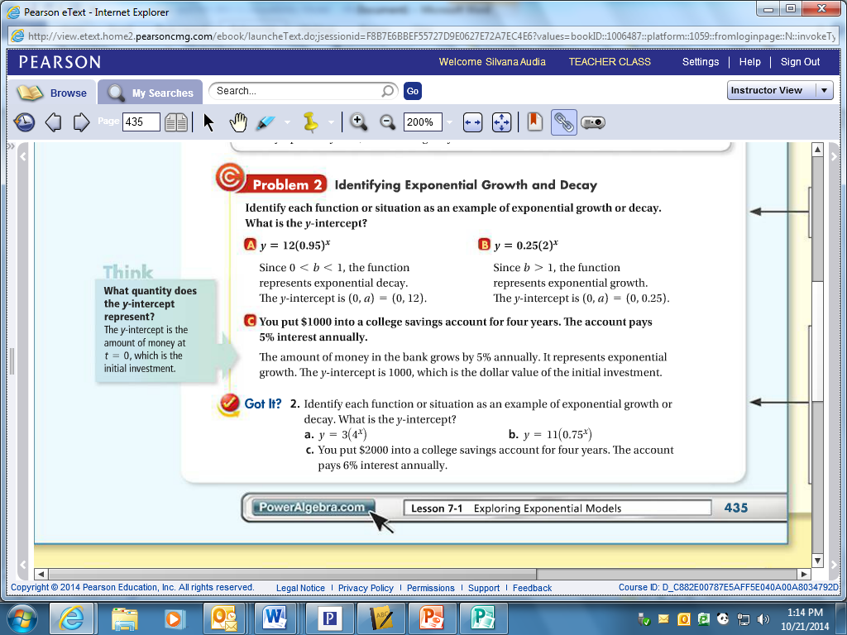

Tell whether each function represents exponential growth or decay. Then find the y-intercept.

1.  ____________________ 2.  _____________________

____________________ _____________________

3.  ____________________ 4.  _____________________

____________________ _____________________

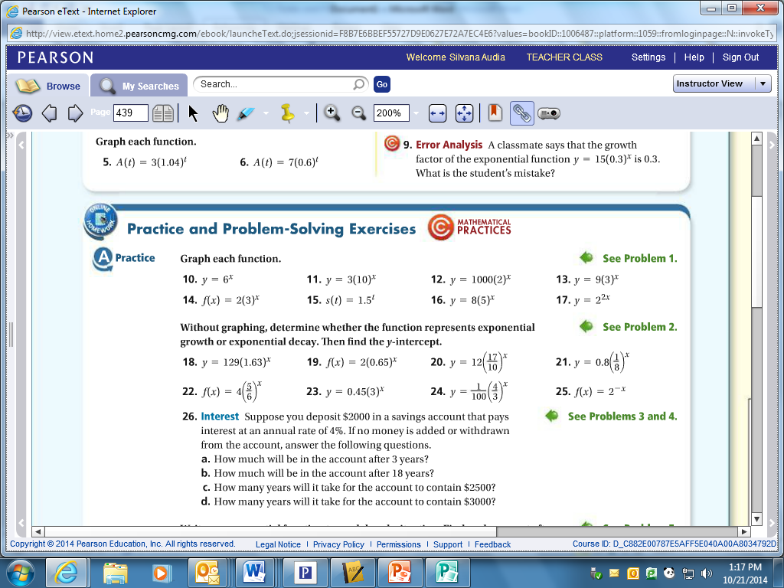



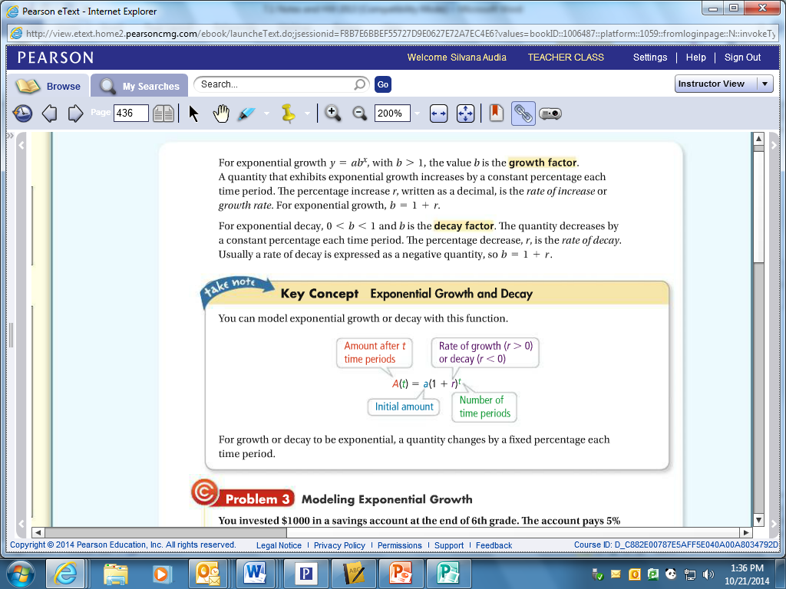

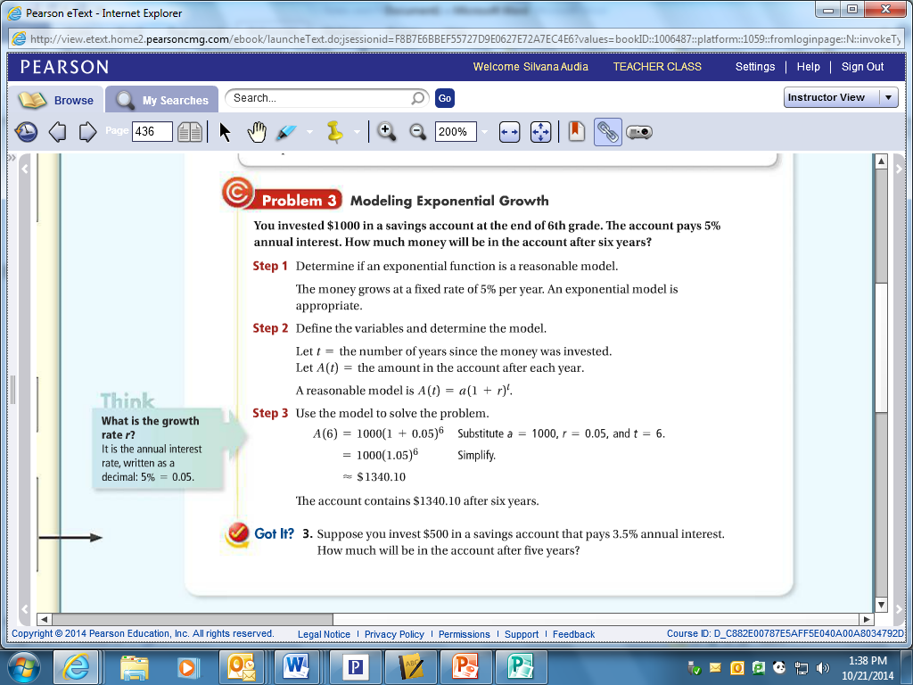

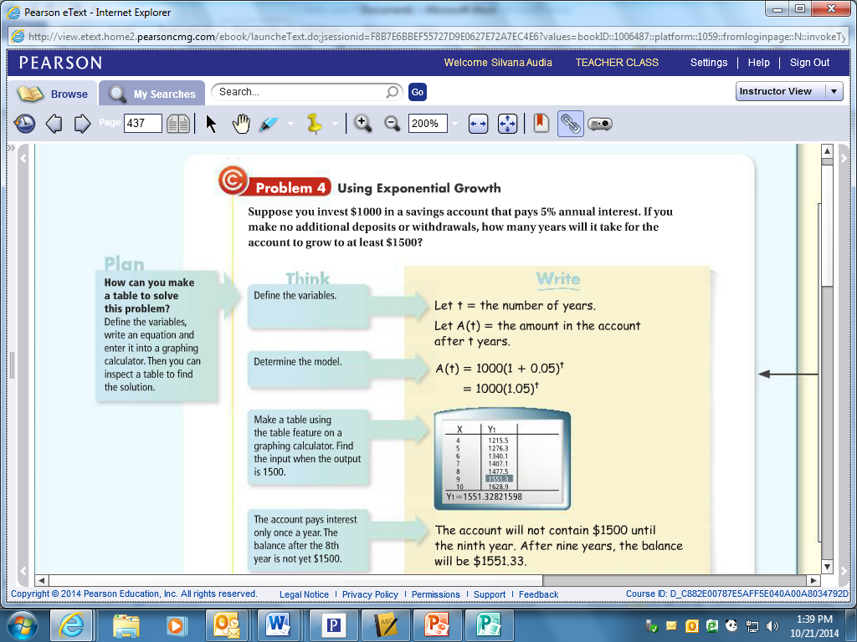

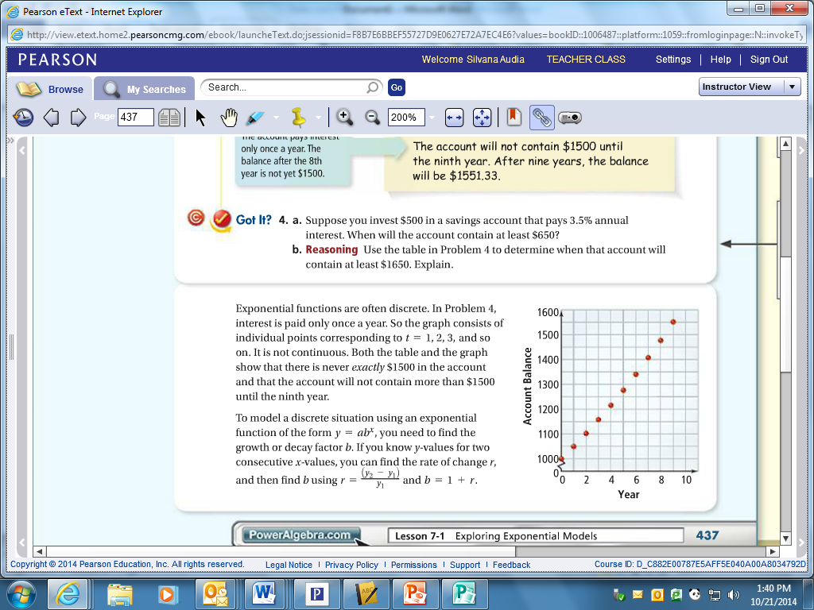

**4.** Suppose you deposit $2000 in a savings account that pays interest at an annual rate of 4%. If no   
 money is added or withdrawn from the account, answer the following questions.

1. How much will be in the account after 3 years?
2. How much will be in the account after 18 years?
3. How many years will it take for the account to contain $2500?
4. How many years will it take for the account to contain $3000?

5. Bacteria reproduce, or grow in number, by dividing. If we have 1 bacteria and it doubles every

hour, how many bacteria would we have after 25 hours. If we have 100 bacteria and

double every hour, how many would we have after 25 hours?

# bacteria

hour

# bacteria

hour

Example 5 is an example of _______________________________.

An equation for exponential growth is  where *a* = __________________________

*x* = ___________________________

*b* = ___________________________

*b* is the ____________________ or ___________________ factor.

Predict the population of bacteria for each situation and time period.

6. 225 bacteria that triple every hour for 7 hours

7. 340 bacteria that double every half hour for 6 hours

When something increases or decreases by a **percent** it is an exponential growth or decay. The growth or decay factor will be ___________________________ where *r* = _________________.

So the equation becomes:  where *a* = _______________________________

*r* = _______________________________

*t* = _______________________________

8. The population of the United States was 248,718,301 in 1990 and was projected to grow at a rate

of about 8% per decade. Predict the population, to the nearest hundred thousand, for 2025.

9. The rate at which caffeine is eliminated from the bloodstream of an adult is about 15% per hour.

An adult drinks a caffeinated soda, and the caffeine in his or her bloodstream reaches a peak

of 30 milligrams. Predict the amount, to the nearest tenth of a milligram, of caffeine

remaining 1 hour after the peak and 4 hours after the peak.

10. A new computer that sells for $1350 depreciates 14% per year. What is its estimated value

after 5 years? Round to the nearest ten dollars.

11. For the given annual rate of change, find the corresponding growth or decay factor.

+500% +250% -50% -2

**Write an exponential function to model each situation. find each amount after the specified time.**

**5.** A population of 120,000 grows 1.2% per year for 15 years.

**6.** A population of 1,860,000 decreases 1.5% each year for 12 years.