Algebra 2 Name ________________________

Notes and Examples DAY 1

Section 7.5 Exponential and Logarithmic Equations Hour _________ Date ___________

An exponential equation is any equation that contains the form  , such as  where the exponent

includes a  **variable** .

A logarithmic equation is an equation that includes one or more **logarithms** involving a

variable.

You can use logarithms to solve exponential equations. You can use exponents to solve logarithmic equations.

EXAMPLES:

Solve each equation for *x*. Round your answer to the nearest ten-thousandth if necessary.

1.  2.  3. 

4.  5.  6. 

7.  8.  9. 











Review



 

To solve an equation that contains logarithms:

* isolate the logarithms on one side by using the logarithm properties to combine the logs
* change to exponential form
* solve.























5.  6.  7. 



7.  8.  9. 



10.  11. 

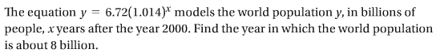

6.

8. Your MP3 player has about 126,000,000 bytes of memory. Each month you plan to use 5% of

the memory remaining. How many months will it take you to use ¼ of the memory?



12.

