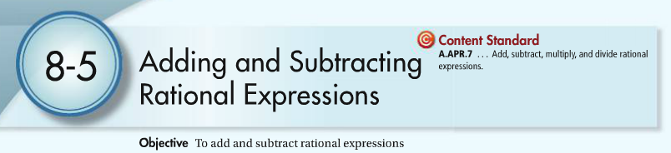

To add or subtract fractions, the fractions MUST have a _____common denominator______.

**Examples. Add or subtract and simplify. State the restrictions.**

1.  2.  3. 

4.  5.  6. 

 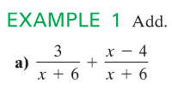

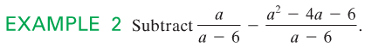 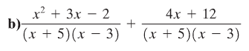

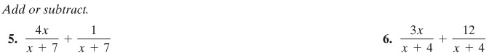





** 12. **

