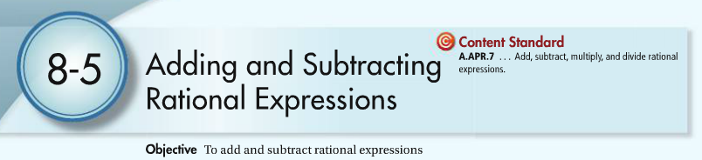

To add or subtract fractions, the fractions MUST have a _____common denominator______.

**Examples. Add or subtract and simplify. State any restrictions on the variable.**

1.  2.  3.  4. 

5.  6.  7. 

**Homework**

**  **

**  **

