Algebra 2 Name__________________________
Notes Section 6.6 Date _______________ Hour_______
Function Operations

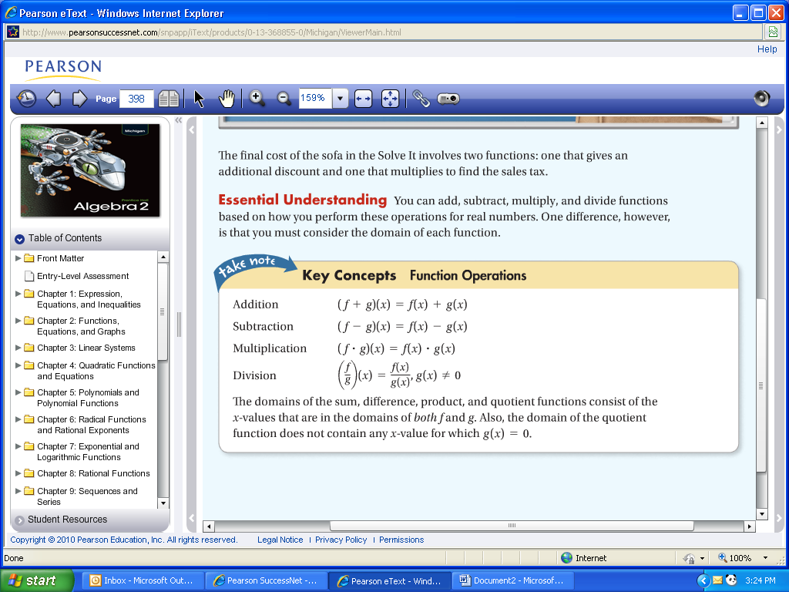

Example 1 Let 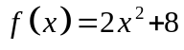 and 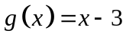. Perform each function operation and then find the domain of the result.
a. 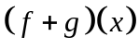 b. 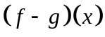 c 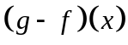

Example 2 Let 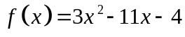 and 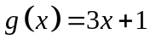. Perform each function operation and then find the domain of the result.
a. 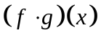 b. 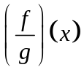 c. 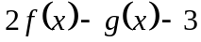

Example 3 Evaluate the function f for the given value. 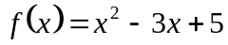 for 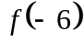

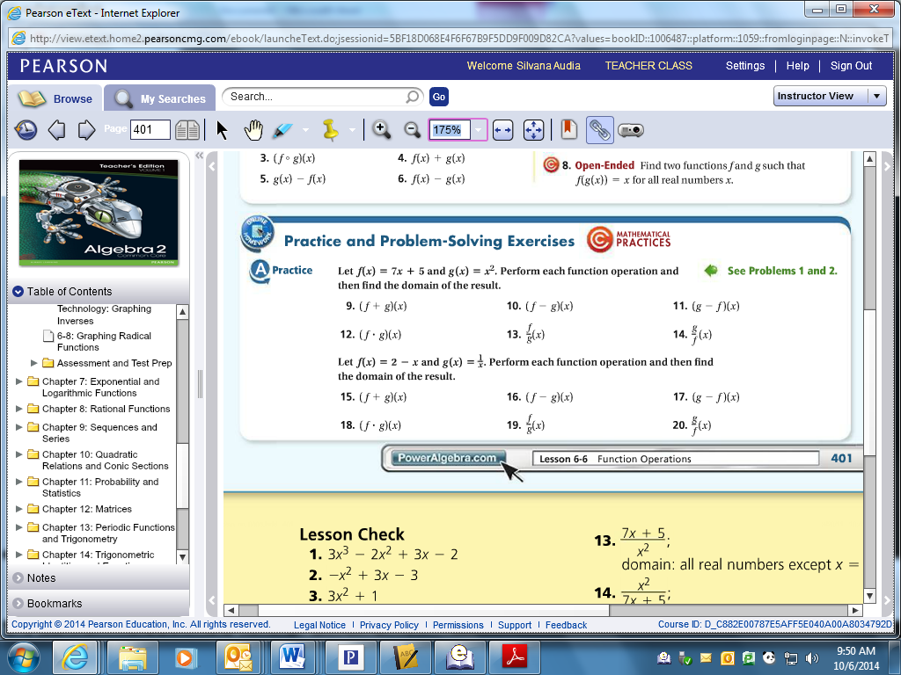

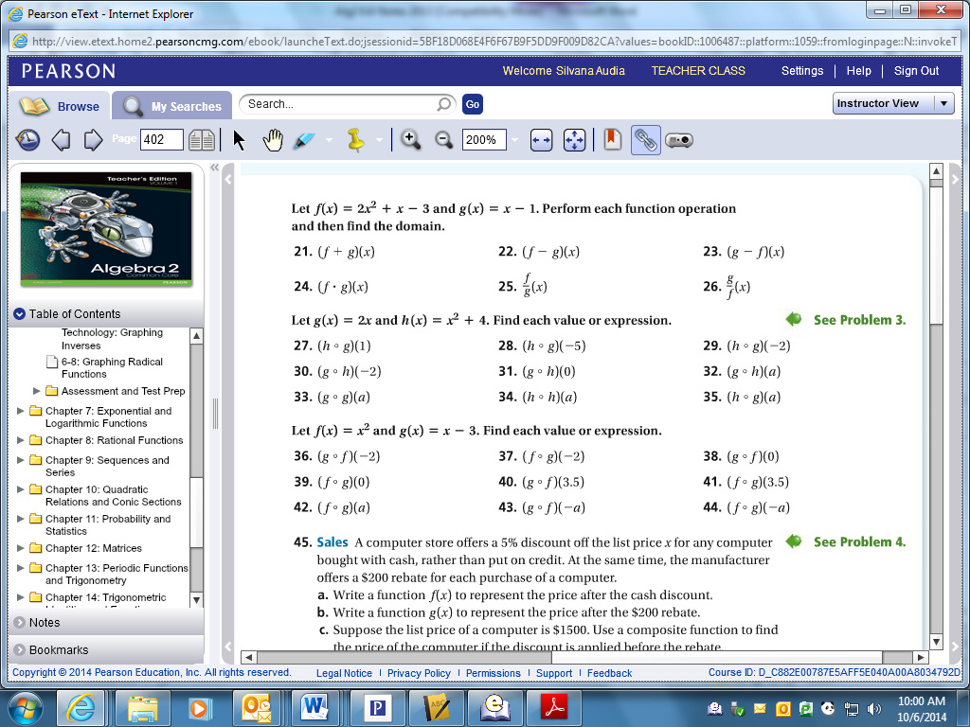

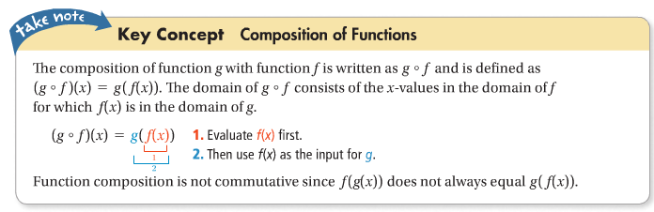

Example 4 Let 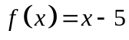 and 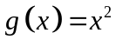. Find each value or expression.
a. 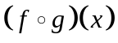 b. 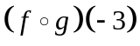 c. 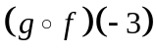

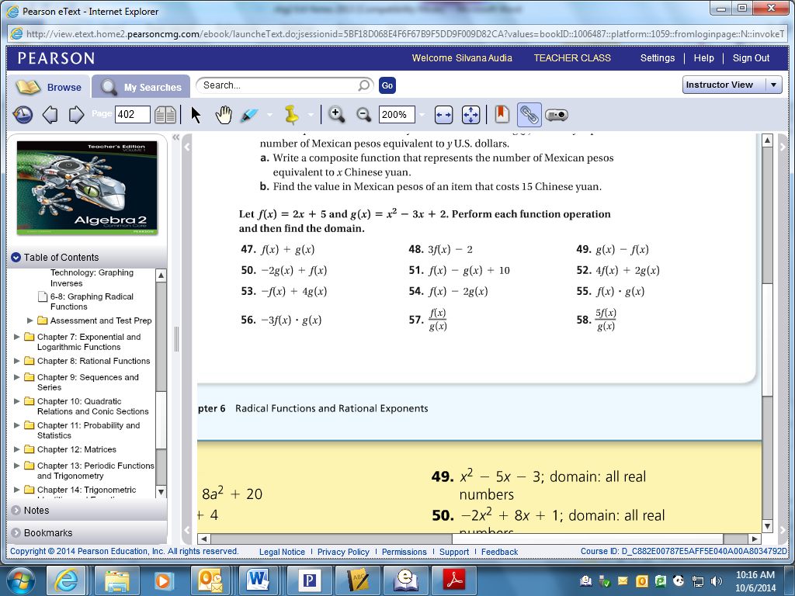

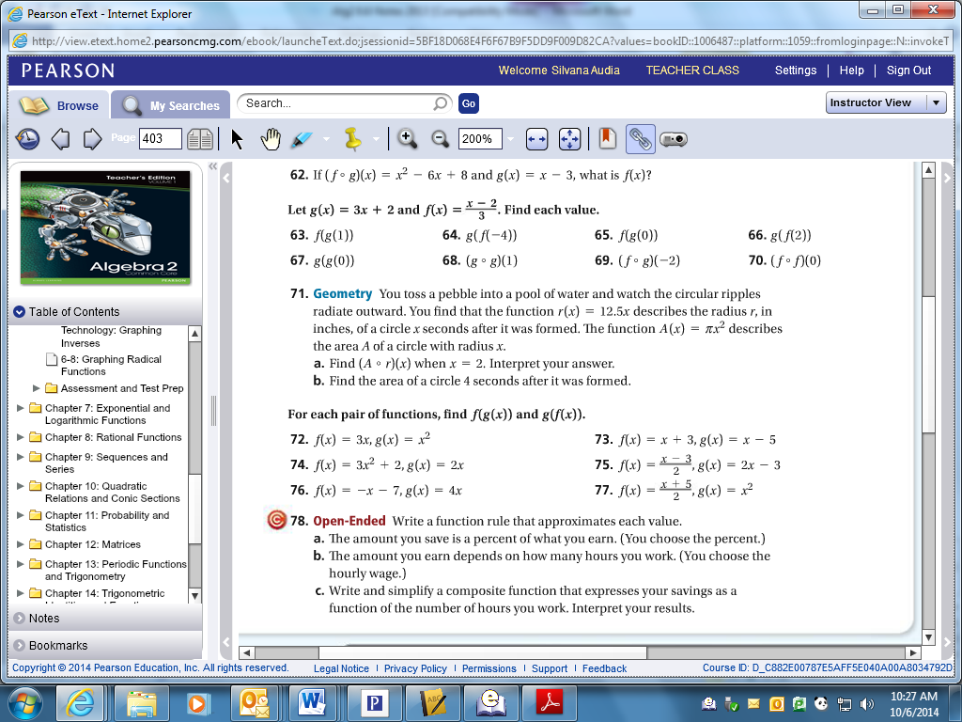

Example 5 Find 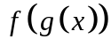 and 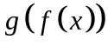 for 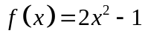 and 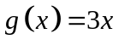
a. = b. =

Example 6 You have a coupon good for $5 off the price of any large pizza. You also get a 10% discount on any pizza if you show your student ID. How much more would you pay for a large pizza if the cashier applies the coupon first?



